#### SMART AGRICULTURE USING IOT

**AN EXPERIENTIAL LEARNING PROJECT REPORT**



**Department of Computer Science and Engineering**

**C. V. RAMAN GLOBAL UNIVERSITY Bhubaneswar - Odisha - India**

#### SMART AGRICULTURE USING IOT

**AN EXPERIENTIAL LEARNING PROJECT REPORT**

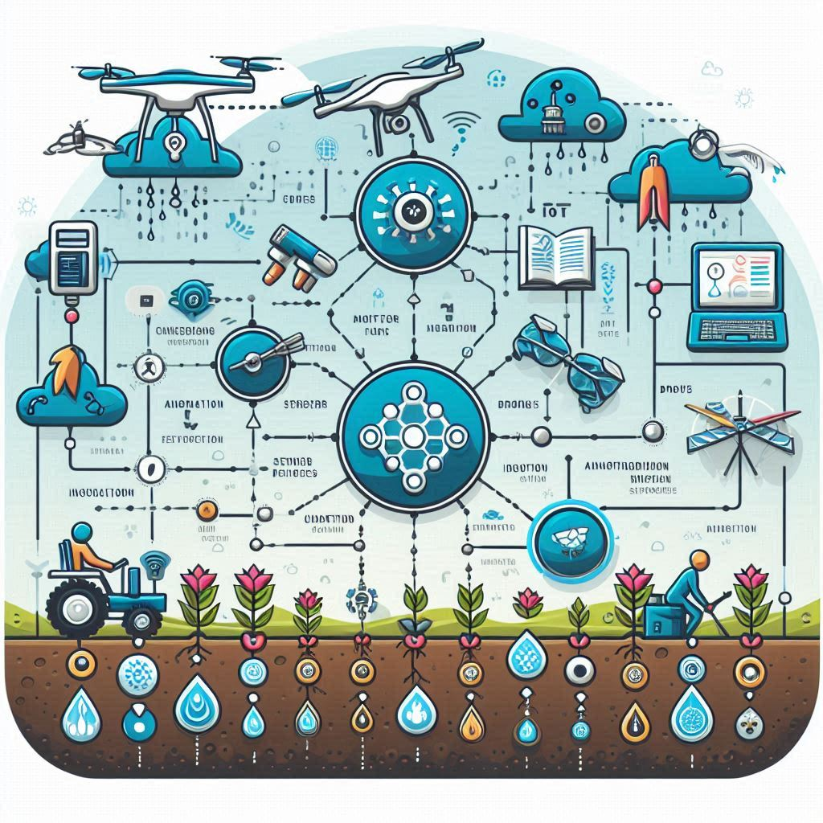

***Guided by:***

Dr. Raj Vikram

**CONTENTS**

|  |  |  |
| --- | --- | --- |
| **S.NO** | **TOPIC** | **PAGE NO** |
| 1. | TEAM MEMBER DETAILS | 4 |
| 2. | CERTIFICATE | 5 |
| 3. | DECLARATION | 6 |
| 4. | ACKNOWLEDGEMENT | 7 |
| 7. | INTRODUCTION | 8 |
| 8. | ABSTRACT | 9 |
| 9. | PROPOSED SYSTEM | 10-17 |
| 11. | ADVANTAGES AND LIMITATIONS | 18-19 |
| 12. | FUTURE SCOPE | 20 |

13. CONCLUSION 21

# TEAM MEMBER DETAILS

|  |  |
| --- | --- |
| NAME | REG. NUMBER |
| SUDHANSU KUMAR | 2201030100 |
| MANGAL MAHARANA | 2101020767 |
| ANURAG RAJ | 2101020762 |
| MAITRIJEET BEHERA | 2101020740 |
| AMAN UJWAL TOPPO | 2201030141 |
| RISHAV KUMAR | 2101020766 |
| PRATYUSH RANJAN MAHANTA | 2201030133 |

**CERTIFIACTE**

#### This is to certify that the project report entitled “SMART AGRICULTURE USING IOT” submitted by our group members to the C.V. Raman Global University in partial fulfillment for the case study/experiential learning is a Bonafede record of project work carried out by them under our supervision.

#### The contents of this report, in full or in parts, have not been submitted to any other Institution or University for the award of any degree or diploma.

#### Signature-

# DECLARATION

We declare that this project report titled “SMART AGRICULTURE USING IOT” submitted in partial fulfillment of The case study/experiential learning is a record of original work carried out by us under the supervision of Dr, Raj Vikram, and has not formed the basis for the award of any other degree or diploma, in this or any other Institution or University. In keeping with the ethical practice in reporting scientific information, due acknowledgements have been made wherever the findings of others have been cited.

**ACKNOWLEDGEMENT**

We have taken efforts in this project. However, it would not have been possible without the kind support and help of many individuals. We would like to extend my sincere thanks to all of them.

We are highly indebted to Dr. Raj Vikram for his guidance and constant supervision as well as for providing necessary information regarding the project and also for her support in completing the project. His constant guidance and willingness to share his vast knowledge made us understand this project and its manifestations in great depths and helped us to complete the assigned tasks on time.

We would like to express our gratitude towards our parents and other friends for their kind cooperation and encouragement which helped us in completion of this project.

Our thanks and appreciation also go to our colleagues in developing the project and people who have willingly helped us out with their abilities.

# INTRODUCTION

Since agriculture is the primary source of food grains and other raw materials, it is the foundation of human existence. In the case of India, agriculture is both the backbone and a key component of the economies of developing nations. People can find massive employment prospects using it. The expansion of the agriculture sector is essential for the nation's economic development. Sadly, a lot of farmers continue to grow crops with low yields due to the old, traditional methods. However, yields have increased when the innovations were put into practice and automated technologies took the position of humans.

Therefore, in order to increase yield, the agricultural sector must employ new technologies. There has been a lot of research and development in the field of agriculture about new IoT technologies. The production of food grains needs to be increased in the current times. A cloud-connected technology facilitates the optimization of crop productivity, assisting with routine agricultural operations and providing real-time monitoring.

Connected equipment has several Wi-Fi connections, which aid in the monitoring and management of electronic machinery to support farmers in crop field analysis and optimal performance. Today, many farmers are able to monitor their land, measure temperature, and moisture content with efficiency thanks to the use of sensor devices and other automated electronics equipment.

**ABSTRACT**

In our nation, agriculture has long been the main industry or source of revenue. However, lately, because of the erratic weather and

the lack of suitable land has made cultivation difficult. As a result, both our nation and the majority of other nations now seriously worry about food security. In order to overcome this, we use the Internet of Things (IoT) in Smart Agriculture systems to increase the sector's productivity and operational efficiency. This system's feature is the development of a sensor-based microcontroller system that can monitor temperature, humidity, moisture, and even the potential movement of animals that could destroy agricultural resources. If there is any disparity, the system will send out an alert message using Wi-fi/3G/4G module to the farmers’ smartphone. Its low cost makes it affordable for all farmers, and its many qualities make it potentially useful in locations with restricted water supplies.

In order to gather data on soil moisture, temperature, and humidity as well as to operate a manually operated motor to distribute water in the field based on demand and make decisions appropriately, we are putting forth an effective and affordable sensor network technology in this project.

# 

# PROPOSED SYSTEM

**SYSTEM OVERVIEW**

The Smart Agricultural system is an increasing trend in our day-to-day life. As technology has advanced, agriculture has benefited from the newest methods and trends.

The connectivity provided by smart agriculture through the use of current Wi-Fi technology is one of its main advantages.

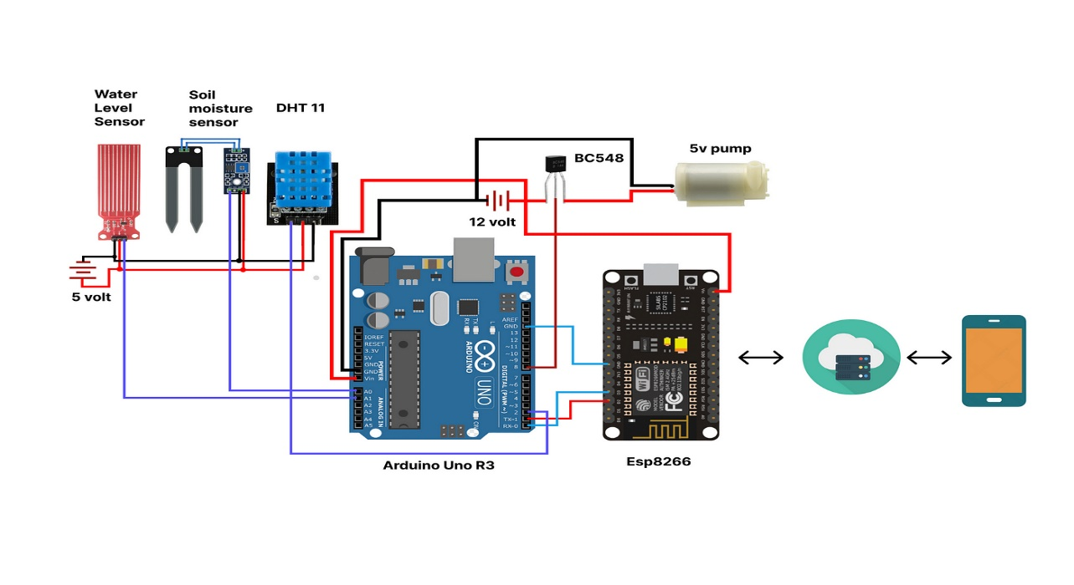

Because it saves time on hardware configurations for Smart Agriculture systems, this technology will contribute to the successful growth of Internet of Things implementation in the agricultural fields. This technology enables to connect devices in real life and solves the current mobile computing scenario of smart devices and associated applications (Apps). The three sensors in this Smart Agriculture System—soil moisture, DHT 11, and ultrasonic sensor—are linked to the ESP8266 Node MCU, which is WiFi-enabled and connected to the internet. The microcontroller receives information from the soil moisture sensor, which measures the moisture content of the soil, and displays it on the Blynk app. The DHT 11 monitors the field's temperature and humidity, sending data to a microcontroller so that the Blynk app can show it. Additionally, the top of the Supplier tank has an ultrasonic sensor that measures the water level in the tank and displays the results in the Blynk app. We can send data to the Blynk app, and we can also receive data from the app. For example, if the water level is low, we can manually turn on Motor 1 to load water from a water reservoir, such as a river, shallow water supply, or water supply, etc., and if we turn on Motor 2, it will distribute water over the agriculture if the soil moisture level is low.

**SOIL MOISTURE SENSOR**

A sensor that measures the amount of moisture in a field is called a soil moisture sensor. The LED in the field will glow when the water level in the Blynk app is low, and it won't shine when the water level is high.

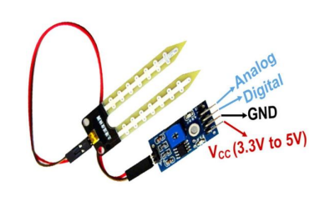

Here, we linked the sensor's digital pin to the microcontroller's GPIO pin, the VCC to 5V, and the GND to the microcontroller's GND. The field's soil conductivity is being indirectly measured by the moisture content of the soil. It is more conductive the more wet it is, and vice versa.

**DHT 11 (Digital Humidity Temperature Sensor)**

Digital Humidity Temperature Sensor (DHT11)is comprised of a thermistor and a humidity sensing component for sensing the temperature. This humidity sensing capacitor has two electrodes with a substrate which contains moisture as a dielectric between them. When the humidity level is change it is seen that the value of capacitance is also changed. The changed resistance value is then change into a digital form with the IC measure process.

When the temperature increases, the resistance value of a thermistor, which has a negative temperature coefficient, decreases. This type of thermistor is used to measure temperature. Typically, this sensor is made of ceramic or polyceramic semiconductor materials to achieve a higher resistance value even at very minor temperature changes.

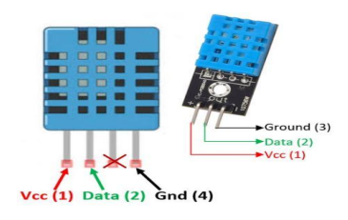

The temperature range of the Digital Humidity Temperature Sensor (DHT11) is 0 to 50 degrees Celsius with an accuracy of 2 degrees. The DHT11 has an accuracy of +/- 5%RH and a sensing range of 20-90%RH. This sensor has a sampling rate of 1Hz, meaning that it provides a reading once every second. The DHT11 has an operating voltage of 5 volts and is incredibly tiny. The maximum current employed for measurement is 2.5 mA.

**ULTRASONIC SENSOR**

The HC-SR04 ultrasonic sensor uses a sound burst to measure the distance to an item. There are two ultrasonic transducers in it. The first device functions as a transmitter, sending out bursts of sound, while the second device, if it receives, generates an output pulse.

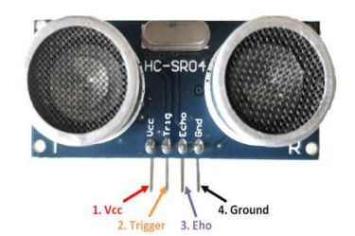

Here, the GND of the ESP8266 Node MCU is linked to GND, while the VCC is connected to the 5V power source. The trigger pin is set to high for a duration of 10µs in order to initiate ultrasonic waves. The module then sends out eight sonic blasts at 40 kHz.Despite having a detection range of 2 to 400 cm, we have adjusted the ultrasonic sensor to 16 cm to meet our needs. After that, the echo pin will receive it and output the time in microseconds. The formula to calculate distance is distance = sound speed × time / 2.

**RELAY**

Relays are employed as electrical switches, and the electronic schematic of one is shown in the figure below. In this project, a relay is employed to activate the water pump in the event that the field's water level drops.

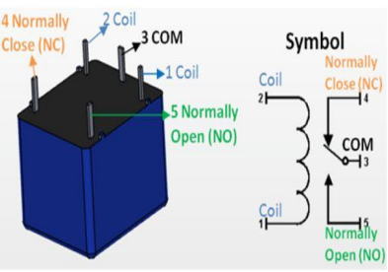

Since the common in the relay is by default set to normally closed, the motor is off and our circuit is open.The circuit is now closed and the motor will operate as a result of the current flowing through the coil, which draws the common connection in the direction of normally open.

**MOTOR**

A Mini Micro Submersible Water Pump is depicted below. The motor runs on DC 3-6V power. It is quite inexpensive, and the pump is tiny. It is possible to pump 120 liters of water every hour while using very little current.

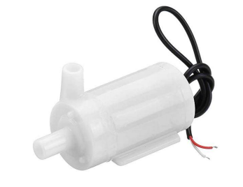

**ESP8266 Node MCU**

Its hardware is built around the ESP-12 module, and its firmware is based on the ESP8266 Wi-Fi SoC. We have utilized pins D1, D2, D3, D4, D5, D6, GND, and VIN in our project.

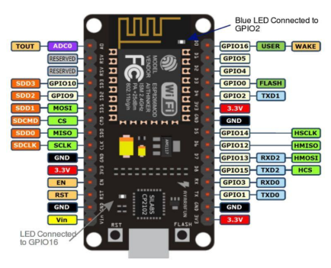

Thirty pins are on it. Through the USB port, we feed it with a 5V power source. It contains one analog I/O pin and sixteen digital I/O pins. a 128 KB flash memory. Clock frequency range: 80–160 MHz. The microcontroller is known as the Tensilica Xtensa LX106 32-bit RISC CPU.

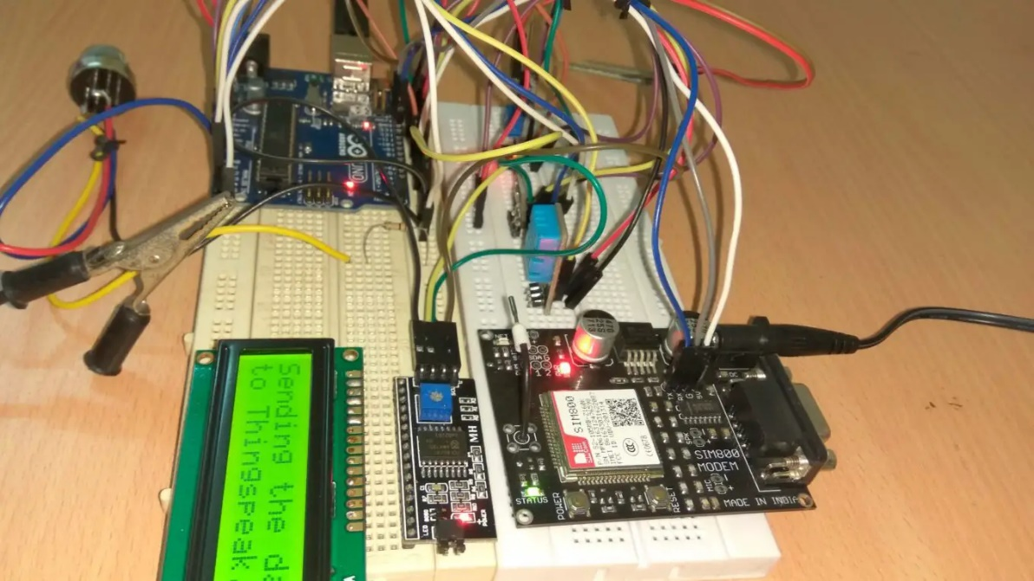

**ARDUINO IDE**

The software in which we are going to write program will be Arduino IDE. The Arduino IDE is an open-source platform for programming which is generally used by programmers to write then compile code using Arduino which is the module. Compiling of code simple and easier so a normal man can understand the learning procedure without any prior coding knowledge because this is the official programming software. For all operating systems like MAC, windows, Linux the Arduino IDE software is readily available.

**BLYNK APPLICATION**

The Mobile App that we will going use for controlling hardware will be BLYNK App. It has the capacity to remotely control hardware and also shows sensor information. To visualize and store data this app also helps. This application has 3 main elements:

1] Blynk app- Different widgets and good interfaces for the projects can be created with the help of this app.

2] Blynk Server- The network between smartphone and hardware is established using this.

3] Blynk Libraries- All commands are processed here whether it be incoming or outgoing.

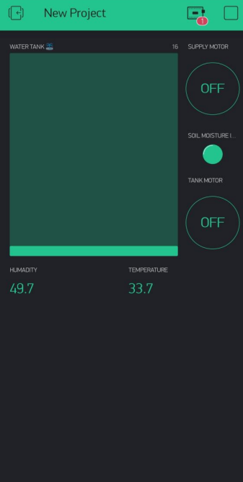

**Sketch Block Diagram**

**RESULT**

Our project's primary goal is to connect the contemporary technology utilized in necessary industries like agriculture. This solution simplifies the use of Internet of Things (IoT) technologies in farm monitoring. In the current agricultural state of affairs, the benefits—which include saving water, saving labor, and, most critically, protecting the crops from poor weather—must be maximized.

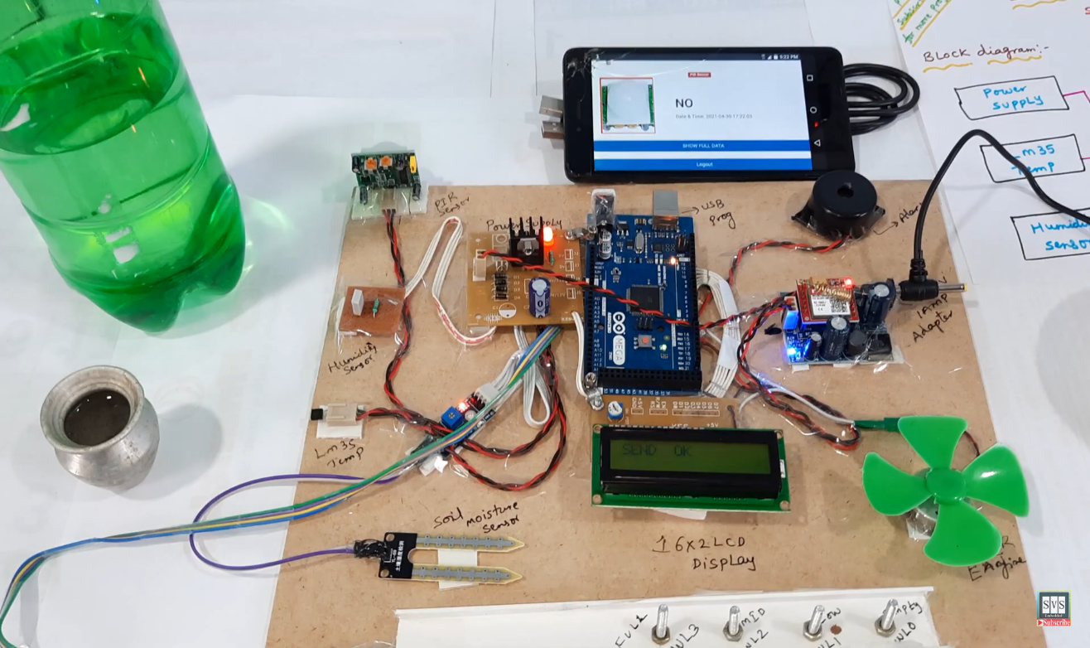

Thus, it is easy to use sensors in the farm field. The user receives the sensor's data via the cloud. Any alterations within the field can therefore be recognized. As a result, early action is accomplished with ease. Figure above displays the hardware kit that we have designed for our planned task.

We may view the temperature and humidity levels in the Blynk application. It will also be evident to us if the soil is wet or dry. The LED will shine if the soil is devoid of water; if it glows, water is present in the soil.

Additionally, we will be able to observe the water level in the tank and refill it as necessary. We also used two motors, the supplier motor is distribute water in the agriculture field if the water level is less in field. And the tank Motor is to refill the Supplier tank if the water level is low and vice versa.

# ADVANTAGES

**Disease Automated Detection:** Computer vision systems can quickly identify signs of disease, pests, or nutritional deficiencies in crops, allowing for early intervention.

**Crop Growth Analysis:** Computer vision tools analyze plant growth patterns, providing insights into plant health, growth rates, and potential yield.

**Yeild Prediction:** By analyzing crop images, computer vision technology can predict potential yields, aiding in harvest planning and resource allocation.

**Soil Moisture Monitoring:** Moisture sensors constantly measure the soil's moisture levels, ensuring plants receive the optimal amount of water.

**Precise Watering:** Based on real-time data, the irrigation system delivers the right amount of water to specific areas, preventing under or over-watering.

**Water Conservation:** By optimizing watering practices, moisture sensor-based irrigation systems promote water conservation and sustainable farming.

# LIMITATIONS

**High Initial Investment:** Establishing a miniature smart farm requires a significant initial investment in technology, equipment, and infrastructure.

**Technical Expertise:** Implementing smart farming solutions demands a certain level of technical expertise in configuring and maintaining the systems.

**Data Management:** The need to effectively manage and interpret large volumes of generated data poses a challenge for farmers adopting smart farming.

# FUTURE SCOPE

# Indian agriculture has large potential and is yet to be fully discovered.

# There is a significant amount of research needed in this field.

# Soil textures vary across different regions of India.

# Implementation of this project will benefit farmers on a large scale.

# Challenges to be addressed include:

# Inter-connection of sensors in agricultural fields.

# Designing a user-friendly application that farmers can easily understand.

# Smart agriculture systems using IoT have vast future potential, including:

# Adding motion sensors to detect animal movement in farms.

# Implementing voice command features in different regional languages to enhance user-friendliness.

# Integrating GPS (Global Positioning System) for accurate location tracking and precise weather reports for farmland.

# Including rain detector sensors to increase system benefits.

# Adding a webcam to capture and display photos on the app.

# CONCLUSION

Through this case study, we give an example of how Existential Model works towards integration of the Internet of Things (IoT) into Indian agriculture. The concept of IOT integration with the traditional practices of agriculture, we put forth a system. By proceeding, we demonstrate the different types of sensors including temperature and moisture sensors which are predominant for current agricultural practice. The sensors act as environmental monitors and are responsible for timely diagnoses of soil moisture conditions, which in turn helps farmers boost crop productivity.

Another explanation is the category of software that controls the connection between these sensors and the central system, the system that is responsible of data collection and analysis. The result is, that the farmers can make corrective decisions quickly basing on real time data.

**REFERENCES**

1. <https://components101.com/modules/soil-moisture-sensor-module>
2. <https://components101.com/sensors/dht11-temperature-sensor>
3. <https://components101.com/sensors/ultrasonic-sensor-working-pinout-datasheet>
4. <https://components101.com/switches/5v-relay-pinout-working-datasheet>
5. <https://www.amazon.in/Stookin-Double-Micro-Submersible-Project/dp/B0839J68QZ>
6. <https://circuits4you.com/2017/12/31/nodemcu-pinout/>
7. <https://www.elprocus.com/a-brief-on-dht11-sensor/>



**For GitHub Repo**